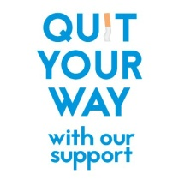
NHS Highland Smoke Free Service

Referral for smoking cessation

Name:
Address:

Telephone Number:
Any other comments:

Date:

Please post to: | Health Improvement  Room 25, The Drumossie Suite  New Craigs, Leachkin Road  Inverness, IV3 8NP
or
Email: | nhsh.stopsmoking@nhs.scot

